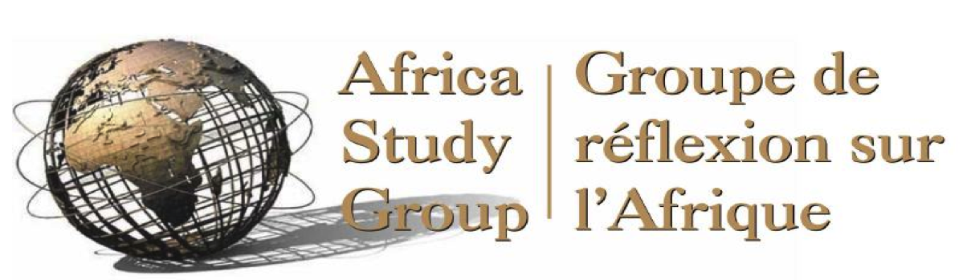

ASG website: www.africastudygroup.ca
Twitter: @AfricStudyGroup

The Africa Study Group Presents:
What Could a Canadian Feminist International Assistance Policy Mean for Africa?

DATE: Wednesday, October 25, 2017
TIME: 5:30-7:30 pm
LOCATION: University of Ottawa, Desmarais Building, Room 1110, Laurier Ave East

1. Opening Remarks

Marcia Burdette, Chair of the Presentation

In attendance: 50

2. Presentation:

Panelists:

Ketty Nivyabandi, Media Advisor for the Nobel Women's Initiative (NWI)
Mariam Diallo, former President of Association Femmes Leadership et Développement Durable (AFLED)
Jane Parpart, Adjunct Professor at University of Ottawa and Carleton University
Amanda Huus, Professor in Political Science at Stellenbosch University

Nivyabandi spoke to the question from two perspectives - her past experience in her home country of Burundi and her current work with a global feminist organization. The NWI had in fact recommended during Minister Bibeau's consultations in 2016-17 that a fund to support women's organizations in developing countries be created, and that the rest of the programming should mainstream feminism into all aspects. Naturally, NWI was pleased with the new policy announced in June 2017 of $150 million over 5 years to support a FIAP which she feels will influence both international organizations and other donors. She noted that gender equality has been at the centre of development conversations, but that it needed to move to the centre of political conversations. She noted that it was important to ensure increased equality of access to resources. She also cautioned against delegating to large NGOs the choice of the women interlocutors in the various developing countries.

Diallo noted that Mali had ratified all the international conventions about women's rights, but did not respect them. The country had no specific laws against GBV or FGM. In terms of the FIAP, she felt it brought “bad news” as well as “good news”. The “bad news” was the fact that the word feminist creates a problem in Mali - and other countries. It was seen as an indication of women taking over as opposed to something more like gender equality. On the other hand, she felt that the policy had several positive aspects: it would provide support for a range of activities in areas outside the conflict zones in Mali - as donors have been almost exclusively focused on those zones in allocating funds in recent years. Funding from the Canadian FIAP would allow a new generation of feminists, or women's advocates in her country, where the movement has not renewed itself in recent years. She hoped that the FIAP would - or should- lead to engendering the components of Mali's strategic planning framework. She also asked how Canada proposed to spend the money from the new fund: in which countries?

Parpart made two strong arguments about the issues around the policy. She noted that gender and sex are not identical, and that the differences need to be better studied. She also noted that unless gender hierarchies and power relations are properly understood, simply adding gender equality to the agenda will not necessarily lead to change.

Huus agreed with Ms Diallo that feminism is a touchy issue in Africa. She felt that much of what had been written was more a descriptive representation than the prescriptive representation that was needed. A key question is how do we put issues of real importance to women onto the legislative agenda? In South Africa, during the lead up to majority rule and early years there were some major achievements for gender equality and improvement in the lives of women. However, today the problems created by factionalism within the ANC - women participants are labelled with the faction to which they belong – means that those factions effectively prevent those women from coalescing on women's issues. In this context, she felt that the ANC Women's League - and similar groups elsewhere - are a big problem in terms of addressing women's issues. She felt that women's empowerment had gone downhill in SA.

3. Discussion:

The discussion was quite wide-ranging: among the themes that were mentioned often were that the proposed fund is quite small when considered across so many countries. Another issue is how would it be allocated. There was concern that the FIAP only addressed development and participants were keen to see it applied as well to the political and trade side - including the issue of mining investment. Several people opined that it was vital to see women included in the peace process- something likely to be key to ending GBV. There was concern that commitment to serious gender analysis was lacking. Also, some participants asked if any African-Canadian analysts at GAC had participated in the development of the policy. This question reflected a more general concern about the policy being supply driven, and another fad of the day that a new Minister would change.

